Diabetes in the 21st Century

Seminar Overview
Are you interested in teaching your patients about diabetes, but find it difficult to keep pace with the latest advances in diabetes care? Then consider attending this all day program that synthesizes the critical elements of diabetes care and education.

Through dynamic presentations and case studies, we will provide you with creative strategies to succeed at teaching in today’s fast paced health care environment.
In addition, small group activities allow participants to improve clinical confidence and diabetes problem solving skills.

Our goal when developing this seminar was to include as many diabetes clinical “pearls” as possible, so participants leave the seminar feeling more empowered and confident advocating for excellence in diabetes care.

Fees and Accreditation

Nurses Provider approved by the California Board of Registered Nursing, Provider #12640 for 7.5 contact hours. Approved for 6.5 CPE II for Registered Dietitians by the Commission on Dietetic Registration.

Registration Fee: $XX for XXXXX employees; $XX for non-employees – includes lunch, syllabus and certificate.

Diabetes in the 21st Century

Schedule

7:30 – 8:30am – Check-in
8:30 – 10:00 am - Overview
- Current State of Diabetes
- Natural History of Diabetes
- Who’s at Risk - Diagnostic Criteria
10:15 – 11:30 am – Goals/Prevention
- Prevention and Exercise
- Educational Strategies that Work
- Getting to Goal - Control Matters

12:30 – 2:00 pm – Hospital Care, Feet and Insulin Therapy
- Managing Hyperglycemia in Hospital
- Lower Extremity Care
- Basics of Insulin Therapy

2:15 – 4:00 pm - Pattern Management, Gut Health, Nourishment
- Insulin and Pattern Management
- Gut Bacteria and Health
- Nourishing our Bodies
- Conclusion

Course Location

XXXX

XXX

XXX

Who Should Attend?
This course is designed for all health care professionals including providers, nurses, dietitians, pharmacists and educators who want to:
- Get re-energized about diabetes care and education
- Enjoy a comprehensive and reality based review of "the basics and beyond" of diabetes management.
- Keep abreast of the rapidly changing strategies in diabetes management
- Refine their skills and improve competencies in diabetes problem solving.
- Learn practical approaches to educating patients about diabetes self-management.

Course Faculty: Beverly Thomassian, RN, MPH, CDE, BC-ADM

Beverly is a nurse entrepreneur, educator and clinician with a passion to improve diabetes care. She has a special knack of translating complex diabetes information into understandable terms that can be immediately applied in the clinical setting.

She also believes that learning about diabetes should be meaningful and fun so participants leave feeling re-energized and excited about diabetes education.
Registration
To assure your space, please register by XXXX
I want to attend Diabetes in the 21st Century Program on XXXXXX. Enclosed is my payment for $XX
I am a XXXXX Employee. Enclosed is my payment for $XX.

Name________________________________

Profession____________________________

Home Address_________________________

__________________________________________________

City _________________________________

State________ Zip ____________________

Ph # ________________________________

Email: _______________________________

Payment
Check made payable to XXXXX
Mail check and completed registration form to:
XXXXX
XXX
XXX

Diabetes in the 21st Century

Presented by
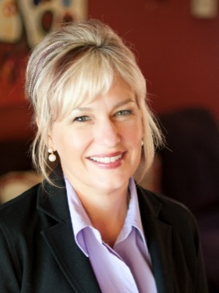
Beverly Thomassian,
RN, MPH, BC-ADM CDE

Date Here 2018
Location Here

7.5 CEUs

