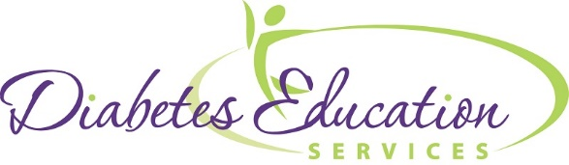
Diabetes and Beyond
Beverly Dyck Thomassian, RN, BC-ADM, MPH, CDE
Diabetes Education Services
www.DiabetesEd.net
8:30 – 8:45am Welcome and Registration
8:45 – 10:00 Diabetes Overview
- Pathophysiology
- Different types of diabetes
- Who's at Risk - Diagnostic Criteria
- Natural history of diabetes
- Insulin Resistance

10:00 – 10:15 Break

10:15 – 11:45 Teaching Strategies, Goals
- Teaching Strategies and problem solving
- Management Goals – Control Matters

11:45 – 12:45 Lunch

12:45– 2:30 Medication Therapy – A Case Management Approach
- ADA and AADE Algorithms
- When to switch to or add Byetta or Tradjenta
- Glipizide plus insulin? Exploring what is best for patient outcomes.
- Identification and treatment of LADA
- Double Diabetes (Type 1 + Type 2) and management strategies

BREAKS A few breaks in between as needed!
2:45 - 4:15 Insulin and Pattern Management Gone Crazy
- Peritoneal dialysis and Insulin Management
- Dawn Phenomenon vs Somogyi – How to manage
- Who should be started on U500 and how to convert them
- Role of BID NPH and 70/30
ACCREDITATION: PROVIDER APPROVED BY THE CALIFORNIA BOARD OF REGISTERED NURSING, PROVIDER #12640 FOR 7.5 CONTACT HOURS. APPROVED FOR 6.5 CPE II FOR REGISTERED DIETITIANS BY THE COMMISSION ON DIETETIC REGISTRATION #D1002

