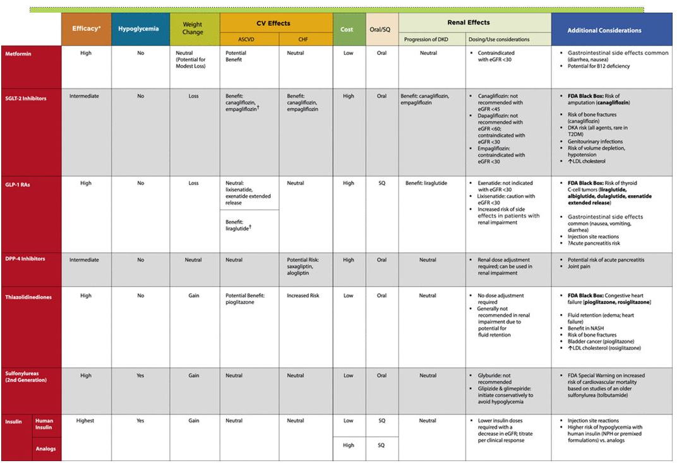ADA Standards of Care, 2018 – Section 8 Unique features of Diabetes Medications

