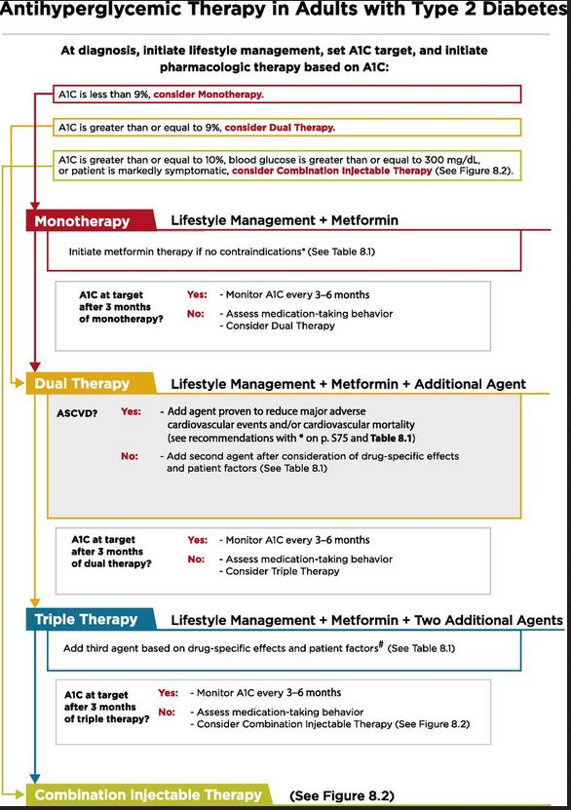
American Diabetes Association Standards of Care 2018, Section 8 - Pharmacologic Algorithm Type 2

