Your Voice Matters!
9 Things YOU CAN do to Prevent & Manage Diabetes

Beverly Thomassian, RN, MPH, BC-ADM CDCES & Diabetes Advocate

Fasting blood sugars tell us about your pancreas health.

Fasting Blood Sugar A1c________

Healthy less than 100 mg/dl less than 5.7%

PreDiabetes 100 – 125 mg/dl 5.7 – 6.4%

Diabetes 126 mg/dl 6.5% or more

9 Things YOU Can do to Prevent and Manage Diabetes

- Get active –30 minutes a day plus strengthening 2 x’s a week.
- Good oral care
- Get enough sleep.
- Don’t smoke and watch alcohol (1-2 drinks or less per day)
- Eat more fiber and super foods. Prepare food at home.
- Avoid sodas, processed foods and limit fast food.
- Get out in nature. Breathe. Have moments of AWE.
- Talk about it.
- Meet with a registered dietitian and diabetes care & education specialist. Keep connect with provider.

Goals for those with Diabetes

A1C – less than 7% ``Blood Pressure – less than 130/80
- Premeal sugar target is 80-130
- 1-2 hours after a meal, less than 180.

Cholesterol – If 40 or older, cholesterol medication (statins) + diet and exercise recommended
- LDL (lousy) cholesterol target less than 70, if at high risk for heart disease
- LDL cholesterol target less than 55, if had heart attack or stroke
- Triglycerides less than 150 & HDL (happy cholesterol) more than 40

Drugs – Know the medications you are taking, keep updated list on phone or paper and
Eyes – Get checked yearly, report any vision changes
Feet – Check them daily, and if you notice and sores or infection, let your provider know
Food - Healthy eating, more fiber, vegetables, beans, whole grains, fruits. Meet with dietitian.
Kidneys – Check for kidney health annually by knowing your:
- GFR (goal is more than 60) and UACR (urine test) with goal of less than 30 mg/gm.
Nutrition Super Foods

Beans
Whether you prefer kidney, pinto, navy, or black beans, you can’t find better nutrition than that provided by beans. They are very high in fiber giving you about 1/3 of your daily requirement in just a ½ cup and are also good sources of magnesium, and potassium.
They are considered starchy vegetables but a ½ cup provides as much protein as an ounce of meat without the saturated fat. To save time you can use canned beans but be sure to drain and rinse them to get rid of as much sodium as possible.

Dark Green Leafy Vegetables
Spinach, collards, kale – these powerhouse foods are so low in calories and carbohydrate, you can’t eat too much.

Citrus Fruit - Grapefruit, oranges, lemons and limes. Pick your favorites and get part of your daily dose of soluble fiber and vitamin C.

Sweet Potatoes
A starchy vegetable packed full of vitamin A and fiber. Try in place of regular potatoes for a lower GI alternative.

Berries
Which are your favorites: blueberries, strawberries or another variety? Regardless, they are all packed with antioxidants, vitamins and fiber. Make a parfait alternating the fruit with light, non-fat yogurt for a new favorite dessert.

Tomatoes
An old standby where everyone can find a favorite. The good news is that no matter how you like your tomatoes, pureed, raw, or in a sauce, you’re eating vital nutrients like vitamin C, iron, vitamin E.

Fish High in Omega-3 Fatty Acids
Salmon is a favorite in this category. Stay away from the breaded and deep fat fried variety... they don’t count in your goal of 6-9 ounces of fish per week.

Whole Grains
It’s the germ and bran of the whole grain you’re after. It contains all the nutrients a grain product has to offer. When you purchase processed grains like bread made from enriched wheat flour, you don’t get these. A few more of the nutrients these foods offer are magnesium, chromium, omega 3 fatty acids and folate. Pearled barley and oatmeal are a source of fiber and potassium.

Nuts
An ounce of nuts can go a long way in providing key healthy fats along with hunger management. Other benefits are a dose of magnesium and fiber. Some nuts and seeds, such as walnuts and flax seeds, also contain omega-3 fatty acids.

Fat-free Milk and Yogurt - Everyone knows dairy can help build strong bones and teeth. In addition to calcium, many fortified dairy products are a good source of vitamin D. More research is emerging on the connection between vitamin D and good health.
Resource Websites: www.diabetes.org, www.eatright.org,

Make a Plan – You are Worth It

My activity Goal for this week ___________________________________________________________________

_______________________________________________________________________________

My Nutrition Goal for this week ___________________________________________________________________

_______________________________________________________________________________

When I meet with my provider, I am going to ask about:

___________________________________________________________________

_______________________________________________________________________________
Preparing for Provider Visit:
- Bring list of medications currently taking or take a picture of the meds you are taking.
- If you are keeping track of your blood sugars, bring in your logbook.
- Consider ahead of time the top 1-2 things you want to address during your visit and write them down.
- If you have a hard time remembering what is said, bring someone with you and write down main points after the visit.
- Ask for a copy of your lab results so you can keep your own personal record.
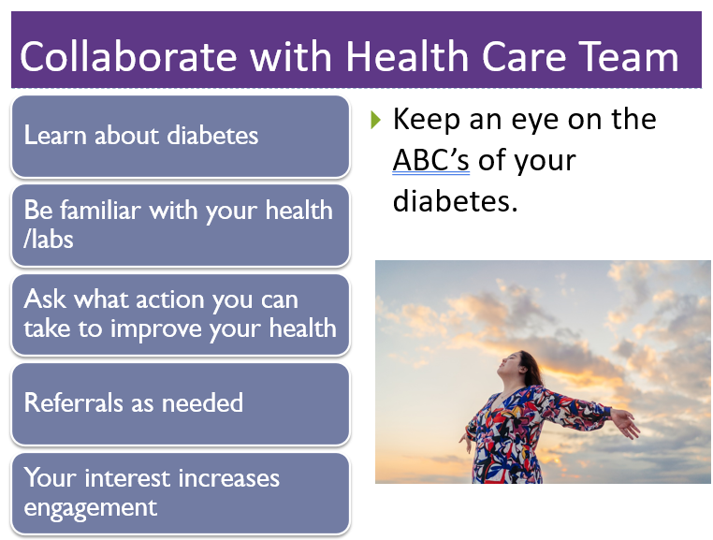
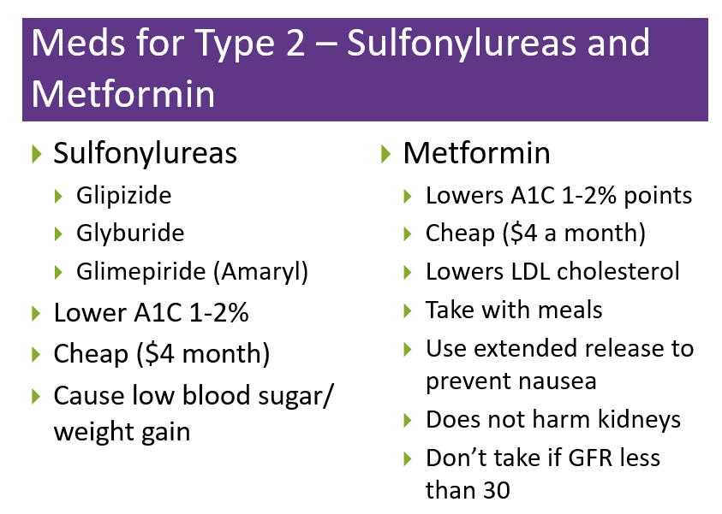

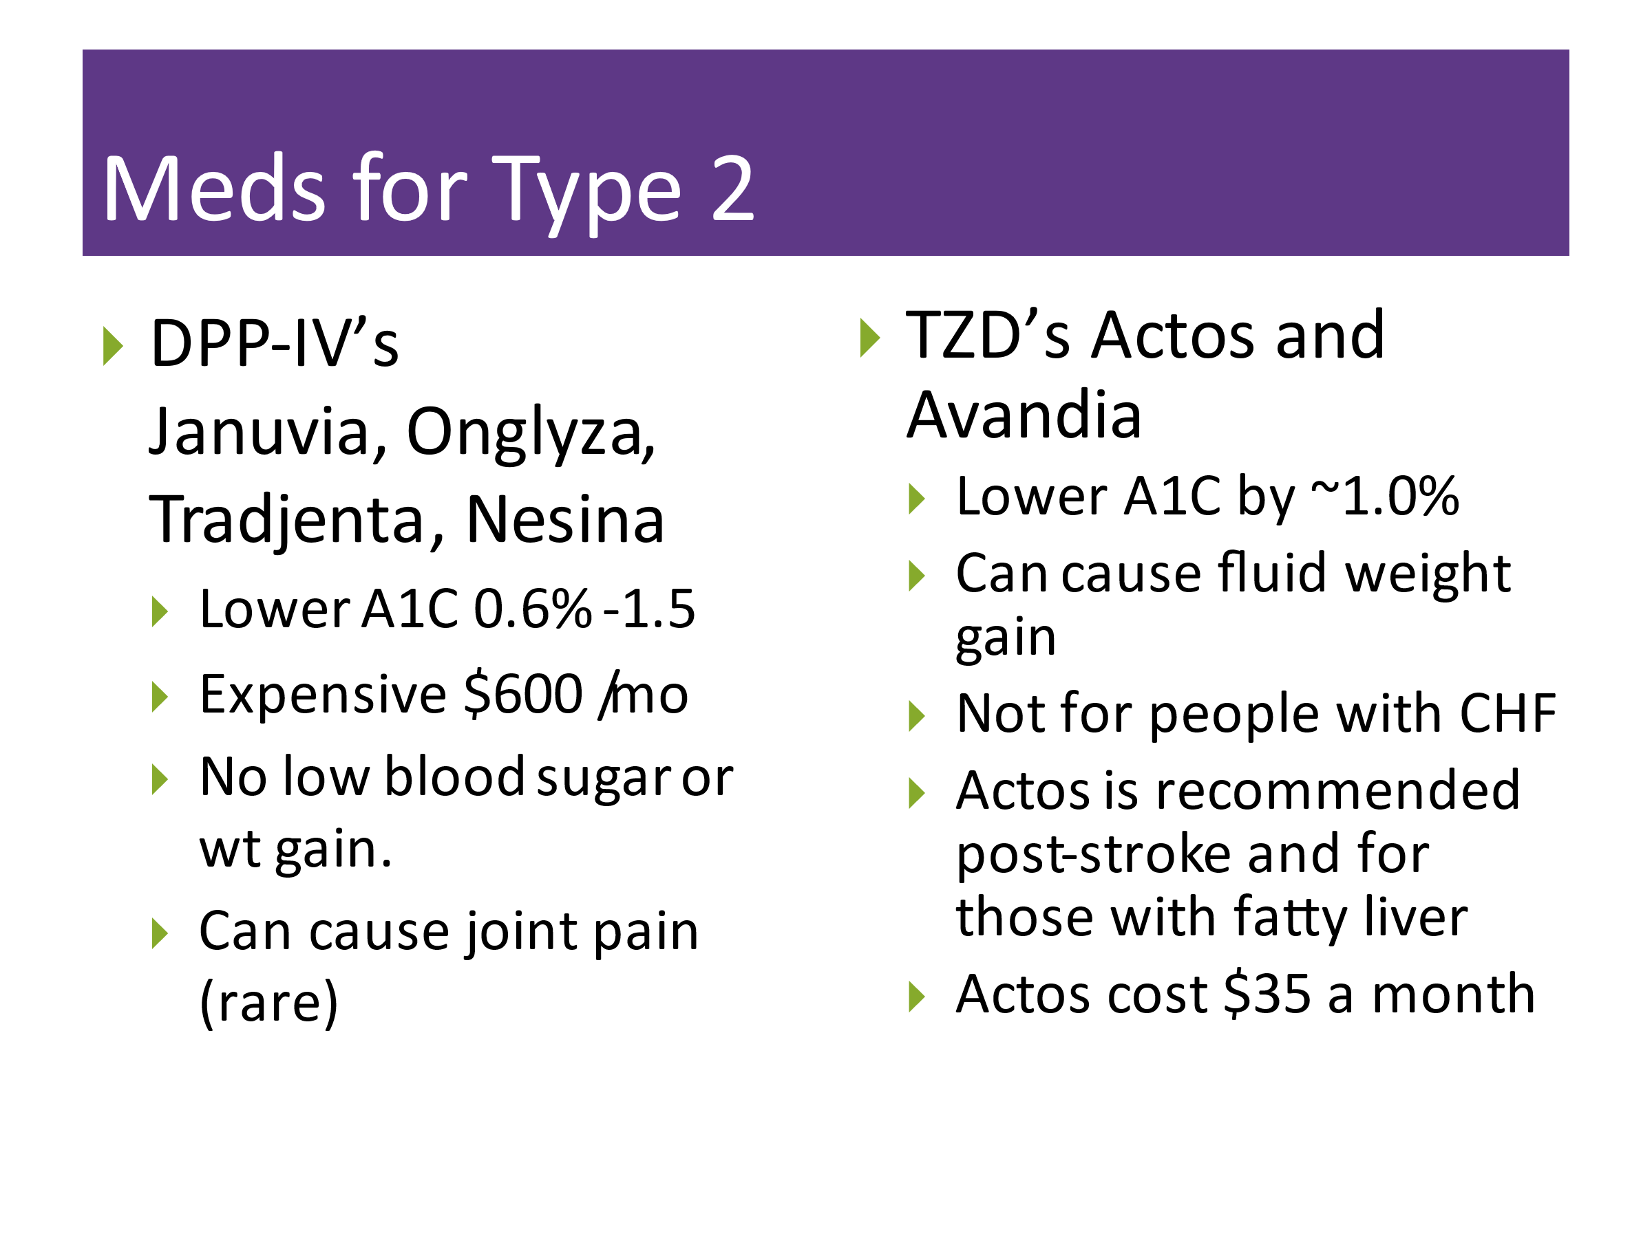

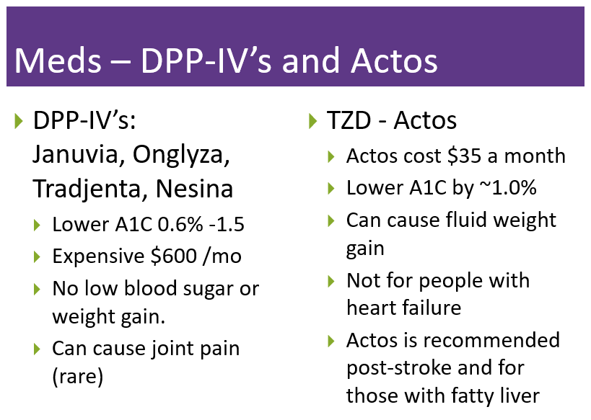

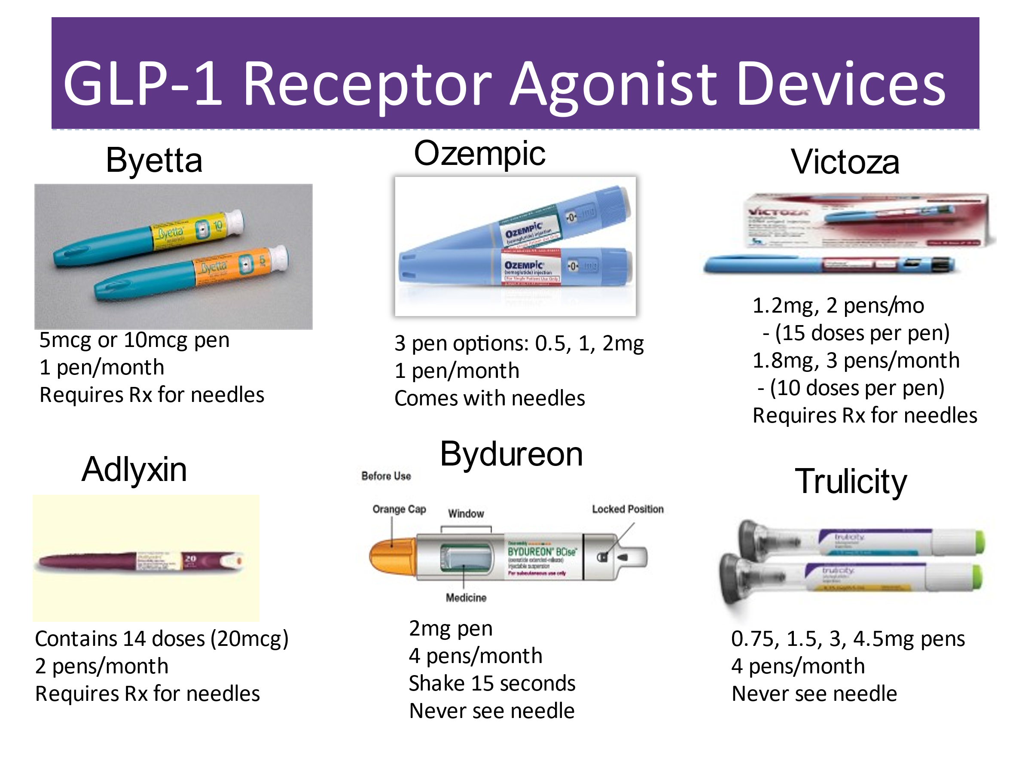
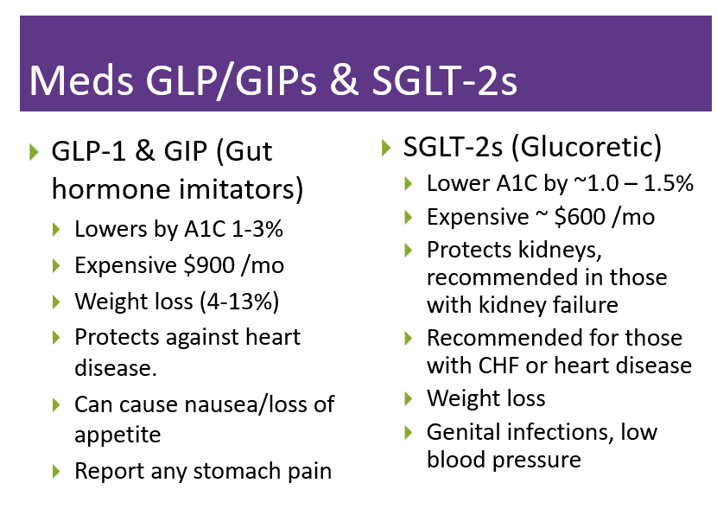

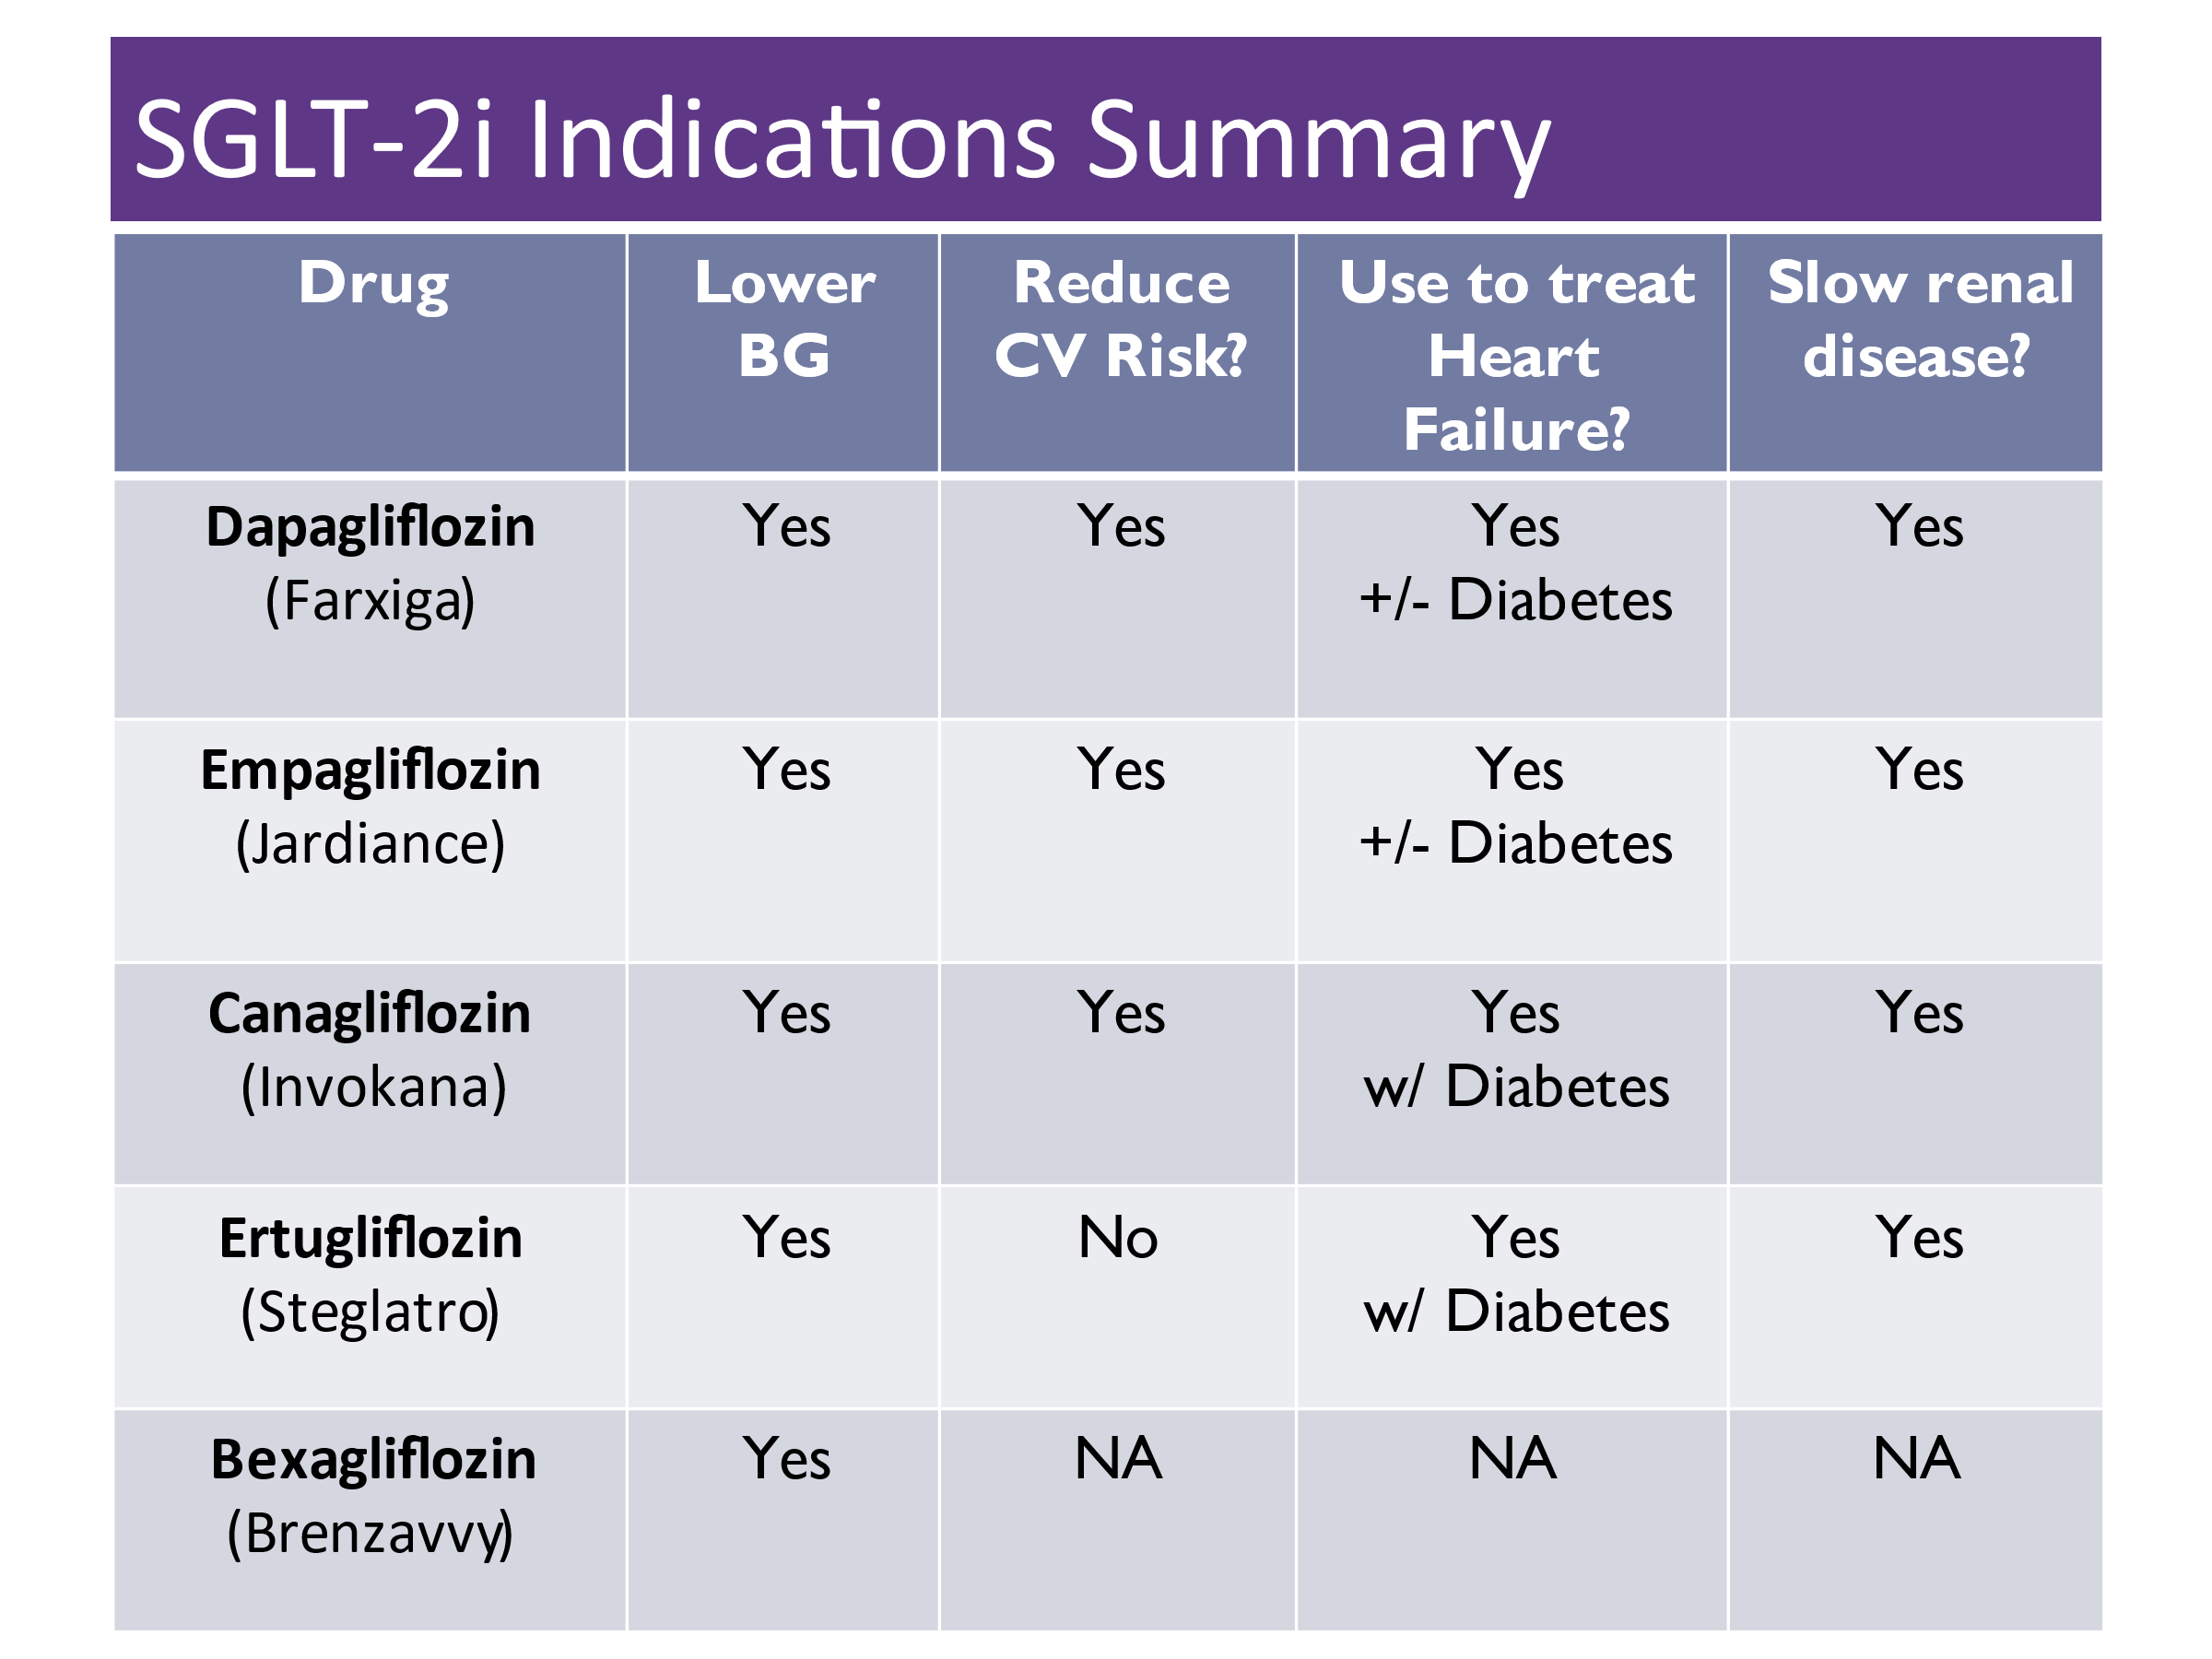
Reframes to Help with Diabetes Burnout or Distress
- It’s not your fault you have diabetes. It’s not your fault your pancreas doesn’t work right.
- You can’t control your blood sugars all the time, but you can take actions to manage your diabetes to the best of your ability.
- Blood sugars are not good or bad, they are just numbers that inform us of what action is needed next.
- Listen to your self-talk. It is tempting to be overly self-critical and blame ourselves. Try to imagine you are coaching a friend with diabetes. What advice or coaching would you provide?
- Diabetes isn’t about perfect or getting it right all the time. It’s about taking baby steps to make small improvements and keep safe.
- Take short mental breaks from your diabetes – walk outside, enjoy a hobby, listen to music, volunteer, join a group.
- Talk about your feelings to friends and family. Let them know how to help you succeed and things that don’t help.
- Keep active, nourish your body, try meditation, enjoy oxygen cocktails, get out in nature.
- Remind yourself of all the work you ARE doing to manage your diabetes.
- Join diabetes camps, social media groups, find your people, your community.
- Consider connecting with a mental health professional.
- Remember, you are not alone. You are resilient. You are not your blood sugars. You got this. Baby Steps

