Stelo: Personalized Choices, Revolutionizing Glucose Health
Dexcom set the standard in CGM innovation for 20 years and counting. Now introducing Stelo, the first FDA-cleared OTC glucose biosensor, designed to empower your patients with prediabetes or type 2 diabetes not on insulin to reach their goals.
Learn all about Stelo: personalizing choices, revolutionizing glucose health

Tracking glucose in the easiest way
No prescription. No fingersticks.* No hassle.
*If the sensor readings are not consistent with the symptoms, a blood glucose meter may be an option as needed.
Providing personalized insights to empower your patients
Built with all the features your patients need and nothing they don’t.
Leveraging nonstop innovation that puts glucose goals within reach
Innovation is always included. Brought to you by Dexcom.

Presented by
DIANA ISAACS,PharmD
Endocrine Clinical Pharmacy Specialist
Co-Director, Endocrine Disorders in Pregnancy
Cleveland Clinic Endocrinology & Metabolism Institute
`
Presented by
Courtyard Marriott Liberty Station
2592 Laning Road
San Diego, California, 92106
Wednesday, October 9, 2024
6:00 PM(GMT-07:00) Pacific Daylight Time
Live Speaker Program

Hosted by
Melanie Kraus
melanie.kraus@dexcom.com
Lola Gugerty
lola.gugerty@dexcom.com
Sabrina Zaslov
sabrina.zaslov@dexcom.com
Register via 833-766-7628|DexcomRSVPs@iqvia.com



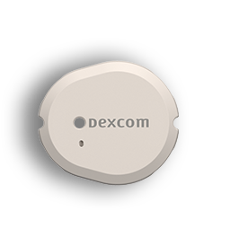
Dexcom, Dexcom Clarity, Dexcom Follow, Dexcom One, Dexcom Share, and any related logos and design marks are either registered trademarks or trademarks of Dexcom, Inc. in the United States and/or other countries. ©2024 Dexcom, Inc. All rights reserved. MAT-4125 v1.0

