Registration Online or by Mail/FAX
Please register 10 days in advance.
I want to attend Diabetes Educator Course Sept 10 – 12, 2014 in San Diego, CA.
Enclosed is payment for $479. – 27 CEs
Please add the Adv Practice Workshop – total 30 CEs. Enclosed is my payment for $519 (save $19)
______________________________________
I want to attend Diabetes Educator Course April 8 – 10, 2015 in Carmel, CA.
Enclosed is my payment for $479 .
Please add the Adv Practice Workshop – total 30 CEs. Enclosed is my payment for $519 (save $19)
Please add the Plant-based Cooking Demo – additional 1.5 CEs. Add an additional $39 to the total
Please sign me up for all of the above. Enclosed is my payment for $558

Method of payment Check Visa MC
_____________________________________

Credit Card Number Exp date: ___________

Name________________________________

Profession____________________________

Home Address_________________________

City _________________________________

State________ Zip ____________________

Ph # ________________________________

Email: _______________________________
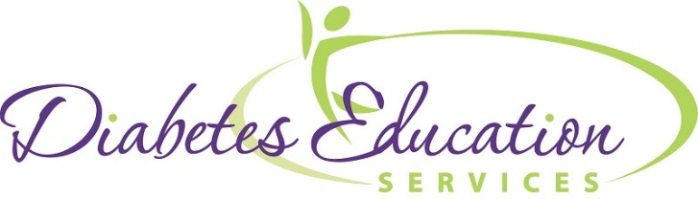
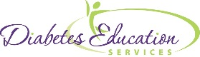

Mail or fax registration to
Diabetes Ed Services
PO Box 3749
Chico, CA 95927-3749
FAX: 815 361-0243

Diabetes
Educator Course



An Intensive Diabetes Workshop for Healthcare Professionals

September 10 – 12, 2014
Island Palms Hotel
San Diego, CA

April 8 – 10, 2015
Carmel Mission Inn
Carmel, CA

www.DiabetesEd.net

Diabetes Educator Course

Seminar Overview
Whether you have some experience in the field of diabetes education or are thinking about taking the Certified Diabetes Educator (CDE) or BC-ADM exam, this course is designed for you. We will provide you with state-of-the-art information at a fast pace. Through lecture, group activities and case studies, our diabetes experts will highlight the critical knowledge, skills and strategies needed to increase your confidence in taking the CDE exam and succeed in diabetes education today!

New - Bonus Online Courses worth 6.0 CEs and Computerized Test
All registrants will receive a special code to access our 6 online courses and 100 computerized test questions for FREE ($89 value)

Speakers and Faculty
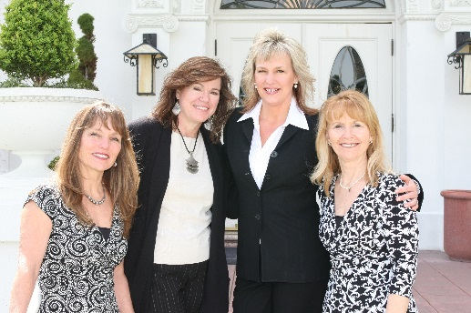

Beverly Dyck Thomassian, RN, BC-ADM, MPH, CDE
Founder Diabetes Educational Services
Dana Armstrong, RD, CDE
Consultant, Diabetes Support Services; Salinas, CA
Diana Pearson, RN, MPH, CDE
Diabetes Care Consultants, San Diego, CA
Lonnie Vaughn, RNC, BSN, CDE
Diabetes Nurse, Doctor’s Med Center, Modesto, CA
Diabetes Ed Course Topics and Information

A perfect blend of the clinical care, science and content needed for certification
- Type 1 and 2 – Natural History
- Insulin: Ultimate Hormone Replacement
- Healthy Coping, Diabetes Education & Motivational Interviewing
- Medications for Type 2 Diabetes
- Complications and Goals of Care
- Medical Nutrition Therapy and Pattern Management
- Exercise Guidelines
- *Free online courses-Preparing for CDE, Program Admin, Hyperglycemic Crisis & more.

Advanced Level Workshop

Already Attending the Diabetes Educator Course? Earn extra 3.0 CEs by adding the Critical Assessment workshop on final afternoon. This interactive workshop led by Beverly Thomassian, uses a case study approach to explore different patients situations and uncover hidden complications and reviews lower extremity assessment in detail. A brief lunch and insulin pump workshop is also included.
__________________________________________________________________________________________________
Course Information
Diabetes Ed Course is from 8 a.m. to 5 p.m. on 1st and 2nd day and 8 a.m. to noon on last day. Reg fee includes computerized exam, free web clinics, syllabus, certificate of completion, breakfast every day and lunch.

Accreditation Information:
This program is approved for 21 contact hours for nurses and pharmacists and 18 CPE, Level III for RDs (Plus 6 CE’s for included online courses) Provider is approved by the California Board of Registered Nursing, Provider 12640 and Commission on Dietetic Registration, Provider DI002. All hours of instruction can be applied toward CDE.
Course Locations

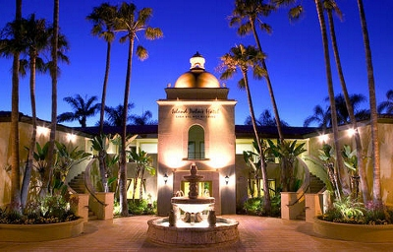
Island Palms Hotel
2051 Shelter Island Dr,
San Diego, CA 92106
September 10 – 12, 2014
A block of sleeping rooms has been reserved. Please book early and mention you are with the Diabetes Education Course to get best rates.
Island Palms: 619-222-0561

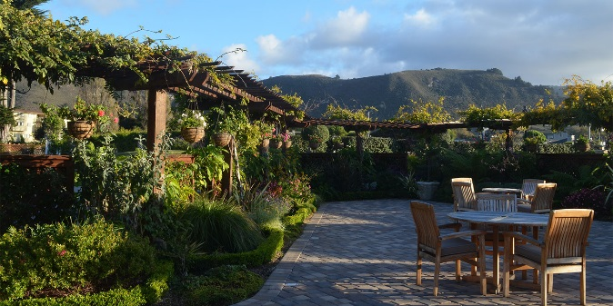
Carmel Mission Inn
3665 Rio Road
Carmel, CA 93923
April 8 – 10, 2015
A block of sleeping rooms has been reserved. Please book early and mention you are with the Diabetes Education Course to get best rates.
Carmel Mission Inn: 800-348-9090

