Registration Online or by Mail/FAX
Please register at least 10 days in advance.
I want to attend Diabetes Educator Course San Diego, CA Sept. 2-4, 2015
Enclosed is my payment for $539 - 31 CEs
Please add the “Pump it Up” Advanced Workshop – total 32.5 CEs. Enclosed is my payment for $30
Please sign me up for all of the above. Enclosed is my payment for $569.
______________________________________
I want to attend Diabetes Educator Course
Monterey, CA April 6-8, 2016
Enclosed is my payment for $539 – 31 CEs
Please add the “Pump it Up” Advanced Workshop – total 32.5 CEs. Enclosed is my payment for $30.
Please sign me up for all of the above. Enclosed is my payment for $569.

Method of payment Check Visa MC
_____________________________________
Credit Card Number
Exp date: ___________ CVV#: ___________

Name________________________________

Profession____________________________

Home Address_________________________

City _________________________________

State________ Zip ____________________

Phone _______________________________

Email ________________________________
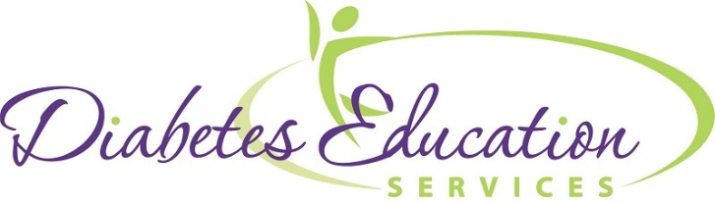


Mail or fax registration to
Diabetes Ed Services
45 Old Chico Way
Chico, CA 95928
FAX: 815 361-0243

Diabetes
Educator Course



An Intensive Diabetes Workshop for Healthcare Professionals

September 2 – 4, 2015
Courtyard – Liberty Station
San Diego, CA

April 6-8, 2016
Hyatt Regency Monterey Hotel
Monterey, CA

www.DiabetesEd.net

Diabetes Educator Course

Seminar Overview
Whether you have some experience in the field of diabetes education or are thinking about taking the Certified Diabetes Educator (CDE) or BC-ADM exam, this course is designed for you. We will provide you with state-of-the-art information at a fast pace. Through lecture, group activities and case studies, our diabetes experts will highlight the critical knowledge, skills and strategies needed to increase your confidence in taking the CDE exam and succeed in diabetes education today!

New - Bonus Online Courses earn 11 CEs
All registrants will automatically receive a bonus bundle of 9 online courses worth 11 CEs and valued at $159.

Speakers and Faculty
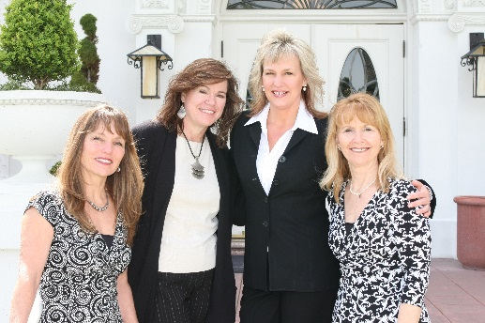

Diane Pearson, RN, MPH, CDE
Clinical Diabetes Specialist, UC San Diego
Dana Armstrong, RD, CDE
Medical Clinic Director, The Diabetes Ctr, Salinas
Beverly Dyck Thomassian, RN, BC-ADM, MPH, CDE
Founder Diabetes Educational Services
Lonnie Vaughn, RNC, BSN, CDE
Diabetes Nurse, Doctor’s Med Center, Modesto

Diabetes Ed Course Topics and Information

A perfect blend of the clinical care, science and content needed for certification
- Type 1 and 2 – Natural History
- Insulin: Ultimate Hormone Replacement
- Healthy Coping, Diabetes Education & Motivational Interviewing
- Medications for Type 2 Diabetes
- Complications and Goals of Care
- Medical Nutrition Therapy and Pattern Management
- Exercise Guidelines
- *Free online courses-Preparing for CDE, Program Admin, Hyperglycemic Crisis & more.

Optional Advanced Workshop

Already Attending the Diabetes Educator Course? Earn an extra 1.5 CEs by adding the Optional Advanced Workshop -“Pump it Up” join us on Friday from 1:30 – 3:00 p.m. and learn about Continuing Glucose Monitoring and insulin pattern management by our expert Dana Armstrong. A brief lunch and insulin pump workshop is also included.
__________________________________________________________________________________________________
Course Information
Diabetes Ed Course is from 8 a.m. to 5 p.m. on 1st and 2nd day and 8 a.m. to noon on last day. Reg fee includes 11 CEs from our Online University, plus 100+ page syllabus, breakfast all days, lunch one day, CE certificates and a fun and engaging learning environment.
Accreditation Information:
This program is approved for 21 contact hours for nurses and pharmacists and 18 CPE, Level III for RDs (Plus 6 CE’s for included online courses) Provider is approved by the California Board of Registered Nursing, Provider 12640 and Commission on Dietetic Registration, Provider DI002. All hours of instruction can be applied toward CDE.
Course Locations
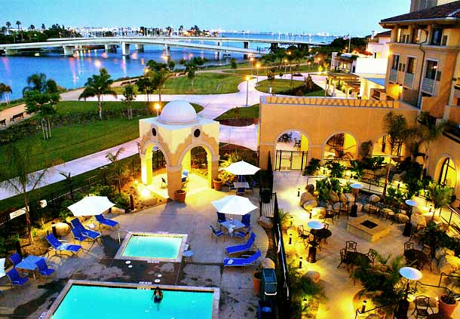
Courtyard by Marriott – Liberty Station
2592 Laning Road,
San Diego, CA 92106
September 2 – 4, 2015
A block of sleeping rooms has been reserved. Please book early and mention you are with the Diabetes Education Course to get the best rates.
Courtyard Liberty Station: 619-221-1900

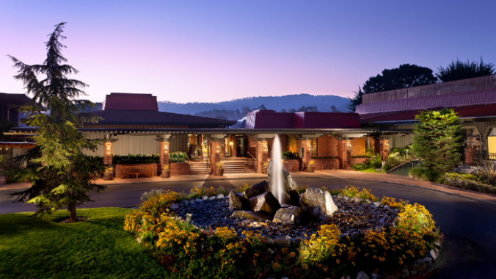
Hyatt Regency Monterey Hotel and Spa
1 Old Golf Course Road
Monterey, CA 93940
April 6-8, 2016
A block of sleeping rooms has been reserved. Please book early and mention you are with the Diabetes Education Course to get the best rates.
Hyatt Regency Monterey: 831-372-1234

