5 Things you can do to Prevent Diabetes

Beverly Thomassian, RN, MPH, CDE

What is Diabetes?

Who is at risk?

If you are overweight (BMI of 25 or greater), have a family history, don’t exercise much, had gestational diabetes and are over the age of 60, your risk is higher.

How do we know you blood sugars are elevated?

Fasting Blood Sugar A1c

Normal less than 100 mg/dl less than 5.7%

PreDiabetes 100 – 125 mg/dl 5.7 – 6.4%

Diabetes 126 mg/dl 6.5% or more


5 Things you can do to Prevent Diabetes
- Get active – Goal is to exercise 30 minutes a day, 5 days a week
- Eat more super foods
- Limit alcohol to 2 drinks a day
- Don’t smoke
- Try to keep a healthy weight – avoid sodas and limit fast food

Websites: www.diabetes.org, www.eatright.org,

Your list of the top 10 Superfoods
All of the foods in our list have a low glycemic index or GI and provide key nutrients that are lacking in the typical western diet such as:
- Calcium, potassium, fiber, magnesium, vitamins A (as carotenoids), C, and E.
There isn’t research that clearly points to supplementation, so always think first about getting your nutrients from foods. Below is our list of superfoods to include in your diet.

Beans
Whether you prefer kidney, pinto, navy or black beans, you can’t find better nutrition than that provided by beans. They are very high in fiber giving you about 1/3 of your daily requirement in just a ½ cup and are also good sources of magnesium, and potassium.
They are considered starchy vegetables but a ½ cup provides as much protein as an ounce of meat without the saturated fat. To save time you can use canned beans, but be sure to drain and rinse them to get rid of as much sodium as possible.

Dark Green Leafy Vegetables
Spinach, collards, kale – these powerhouse foods are so low in calories and carbohydrate, you can’t eat too much.

Citrus Fruit
Grapefruit, oranges, lemons and limes. Pick your favorites and get part of your daily dose of soluble fiber and vitamin C.

Sweet Potatoes
A starchy vegetable packed full of vitamin A and fiber. Try in place of regular potatoes for a lower GI alternative.

Berries
Which are your favorites: blueberries, strawberries or another variety? Regardless, they are all packed with antioxidants, vitamins and fiber. Make a parfait alternating the fruit with light, non-fat yogurt for a new favorite dessert.

Tomatoes
An old standby where everyone can find a favorite. The good news is that no matter how you like your tomatoes, pureed, raw, or in a sauce, you’re eating vital nutrients like vitamin C, iron, vitamin E.

Fish High in Omega-3 Fatty Acids
Salmon is a favorite in this category. Stay away from the breaded and deep fat fried variety... they don’t count in your goal of 6-9 ounces of fish per week.

Whole Grains
It’s the germ and bran of the whole grain you’re after. It contains all the nutrients a grain product has to offer. When you purchase processed grains like bread made from enriched wheat flour, you don’t get these. A few more of the nutrients these foods offer are magnesium, chromium, omega 3 fatty acids and folate.
Pearled barley and oatmeal are a source of fiber and potassium.

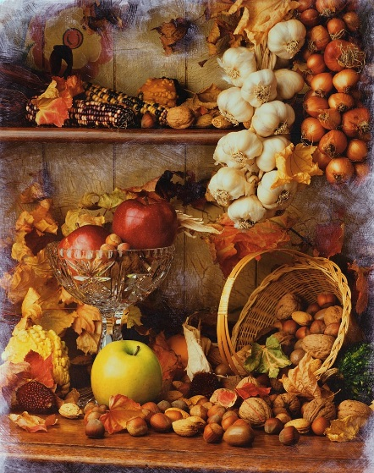
Nuts
An ounce of nuts can go a long way in providing key healthy fats along with hunger management. Other benefits are a dose of magnesium and fiber.
Some nuts and seeds, such as walnuts and flax seeds, also contain omega-3 fatty acids.

Fat-free Milk and Yogurt
Everyone knows dairy can help build strong bones and teeth. In addition to calcium, many fortified dairy products are a good source of vitamin D. More research is emerging on the connection between vitamin D and good health

