What We Wish We Knew: Lessons from Diabetes Entrepreneurs

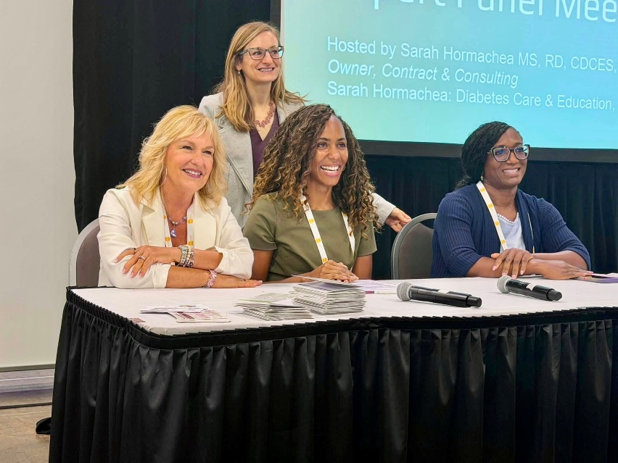
Sarah Homarchea, RD, MS, CDCES, BC-ADM, Entrepreneur panel session for ADCES26, and it was a hit. With over 100 attendees and with standing room only. Sarah was pleasantly surprised that this event was given a premium, non-compete Sunday time slot in the exhibit hall. The turnout was incredible, and it reinforced just how much interest and appetite there is for entrepreneurship within our field.

We asked the panel of speakers, along with the panel moderator, Ms. Hormachea, to share their top pieces of wisdom for diabetes health care professionals who are thinking about starting their own side-hustle or consulting gig, each of the 4 panel members had some fantastic advice and insights to share.
Pictured Above from Left to Right – Presenting At ADCES
Beverly Thomassian, RN, MPH, CDCES, BC-ADM www.DiabetesEd.net
Sarah Hormachea, MS, RD, CDCES, BC-ADM https://www.sarahhormachea.com/
Russ Powell, MS, RD, CDCES, BC-ADM https://www.russpowellnutrition.com/
Vivian Ayuk, PharmD, CDCES https://www.sorogi.com/

Introduction by Sarah Hormachea
As diabetes care and education specialists, our expertise is in high demand, but there are rarely enough of us to go around. Many clinics also lack the resources to bring that expertise on full-time. Entrepreneurship offers creative ways to bridge that gap, expanding access to high-quality diabetes care while creating new opportunities to use our expertise.

When I first ventured into entrepreneurship, it felt scary, uncertain, and largely uncharted. There was no playbook. I decided the best way to understand what was possible was to learn from those who had gone before me. Admittedly, my own desire to learn from the pros helped inspire the idea for an entrepreneurship panel, where I could ask the questions many of us want answered and perhaps uncover a few industry secrets along the way.

With that, I’m pleased to turn it over to our panelists to share their experiences, insights, and words of wisdom.

We asked the panelists to share 3 or 4 takeaways that they felt could most benefit diabetes healthcare professionals considering taking a dive into entrepreneurship. Here is what they said.

Russ Powell, MS, RD, CDCES, BC-ADM

1. Build the business model around the outcome you want your clients to reach, not around the format you are most comfortable delivering.
When I started my practice in 2019, I assumed one-to-one care was the only serious way to do clinical work. What I learned is that the delivery model has to match where the person actually is. Someone newly diagnosed and still in shock needs a different container than someone two years in who just wants a plan they can follow on their own. That is why my practice runs as a hybrid now, with one-to-one coaching through both insurance and private pay, a self-paced course, and group programming. The clinical standard does not change across those formats. What changes is the level of access, and pricing your work along that spectrum lets you serve more people without diluting the care or burning yourself out trying to be everywhere at once.

2. You do not have to jump without a net, and staying employed while you build is not a lack of commitment.
There is a story in entrepreneurial circles that the leap must be total and immediate. That story leaves out how many of us built something durable precisely because we were not making desperate decisions with our pricing or our client selection. While starting my practice, I held a corporate role while growing my business, and that stability let me say no to work that was not the right fit, invest in systems before I technically needed them, and let the business grow at a pace that made clinical sense. Build your runway, define your exit trigger using concrete numbers rather than feelings, and then move.

3. Your systems turn a practice into a business, and you should build them before you feel ready.
The clinical training we get is excellent. The business training is nearly nonexistent, so most of us learn operations the expensive way. The things that separated my practice from a very busy job were unglamorous: a documentation workflow I could actually sustain, clear standards for when clients hear back from me, insurance credentialing done correctly the first time, and written procedures for the tasks I repeat every week. Systems protect your time, and protecting your time is what makes you available for the deep clinical thinking your clients are actually paying you for. If you are waiting until you are big enough to need SOPs, you are already past the point where they would have saved you the most.

Vivian Ayuk, PharmD, CDCES https://www.sorogi.com/

Coach Beverly Thomassian

I can’t think of a better way to capture the importance of authenticity - of knowing who you are, what you stand for, and staying true to those values as you build your business - than these wise words from Dolly Parton:

“Find out who you are and do it on purpose. And do it with purpose. Don’t ever sacrifice who you are, your principles and your morals and your values to just try to get ahead in business. It ain’t worth it.” ~Dolly Parton

1. Let your purpose guide your decisions.
There will always be new opportunities, competing priorities, and plenty of advice about what you should do. Keep coming back to your why. Ask yourself: Does this opportunity align with who I am, the people I want to serve, and the difference I want to make? Your purpose can be your compass when the path forward isn’t clear.

Coach Bev wisdom: “Pursue opportunities that align with your purpose.”

2. Stay curious—and treasure the people you serve.
Successful entrepreneurs need to build community and invest in people. Ask questions. Listen carefully. Pay attention to what people are struggling with, what they’re asking for, and what would make their lives better. Your customers will help you steer the ship in uncertain waters.

Coach Bev wisdom: “The greatest growth in my business has come not from marketing campaigns, but from listening to, learning from, and cherishing the community we serve.”

3. Learn the business of running a business.
You may be passionate about your work, but being an entrepreneur also means learning how to run a healthy business. Educate yourself about bookkeeping, budgeting, taxes, contracts, pricing, insurance, and cash flow. Know your numbers, understand where your money is coming from and where it’s going, and hire experts when you need them. You don’t have to become an accountant, but you do need to understand the financial health of your business.

Coach Bev wisdom: “Follow your passion—but know your numbers.”

4. Build something that reflects your values and be generous with information sharing.
Success isn’t only about revenue or growth. It’s about creating something you’re proud to put your name on. Treat people well, surround yourself with good humans, give back when you can, and make sure your work still brings you a sense of purpose and joy.

Coach Bev wisdom: “Build a business that makes a living—but also makes a difference.”

